Date : 1/11/2015 | Current Price: $23.17 | Recommended: Hold
Ticker : WB CN: TSX | Headquarters: Whistler, BC | Target Price: $22.16

Team D – Student Research
Ski & Snowboarding Resorts
Toronto Stock Exchange

Whistler Blackcomb
Key Financials&Ratios | 2015 | 2016E | 2017E | 2018E | 2019E | 2020E
Revenue | $ 262.25 | $ 285.00 | $ 295.30 | $ 303.40 | $ 310.50 | $ 316.90
Net Income | $ 13.33 | $ 18.04 | $ 21.29 | $ 35.70 | $ 38.61 | $ 40.98
Net Profit Margin | 7.8% | 10.0% | 10.5% | 10.8% | 11.1% | 11.4%
Operating Margin | 19.4% | 24.1% | 24.7% | 25.2% | 25.7% | 26.1%
Interest Coverage | 4.25 | 7.42 | 7.89 | 8.27 | 8.61 | 8.92
Dividend Coverage | 0.55 | 0.77 | 0.83 | 0.89 | 0.93 | 0.97
LT-Debt to Assets | 29.3% | 29.4% | 29.5% | 29.6% | 29.7% | 29.7%
Return on Equity | 5.1% | 7.3% | 8.0% | 8.6% | 9.1% | 9.5%
In Million CAD
Market Profile
Closing Price | $ 23.17
52-Week High/Low | $17.67-$25.37
Average Volume | 40.78 Millions
Diluted Shares Out | 38.15 Millions
Market Cap | 882.07 Millions
Dividend Yield | 4.35%
Beta | 0.6
EV/Revenue | 4.46
EV/EBITDA | 12.37
Institutional Holdings | 75.54%
Insider Holdings | 0.48%
More Destination Visitors: Whistler is currently seeing a large influx of international, destination savings and marginal benefits they receive skiing in Whistler and spending Canadian dollars.
Long-term Outlook and Focus on Stability: Whistler Blackcomb has very lengthy and detailed plans that are well observed by stakeholders and the marketplace. Heavy regulatory requirements provide long term clarity to investors who are able to see well-planned-out future operations resistant to sudden abrupt changes.
Existing Infrastructure and Available Capacity: Whistler has the highest lift capacity out of the top North American ski resorts which is 18% higher than their main competitor, Vail. They provide an all-inclusive resort experience that is able to generate revenues through many different segments.
Minimal Capital Expansion Plans: Whistler has just completed the Peak2Peak Gondola and have recently begun a program to provide snowmaking and enhanced terrain maintenance to their glacier skiing assets. The company has no major expansion plans in the future with regards to new ski runs and the company is especially hesitant to engage in any overly aggressive expansion or acquisition strategies.
Valuation: Valuation methods indicate a current intrinsic price of $21.57. WB offers short-term growth through its demand drivers such as the depressed Canadian Dollar and excess capacity. However, it may be exposed to risks such as dividend risk and long-term debt risk.

Recent News
- Recently launched WB+, a new web and mobile platform connected to the resort’s RFID technology.
- Whistler Blackcomb is on its way to a possible record snow season
- Record level of visits to date in company’s history, 604,000 visitors through January 6th, compared to 514,000 for prior fiscal year.

Business Description

Located 125km from Vancouver, BC, Whistler Blackcomb (WB) is the largest and most visited ski resort in North America, receiving an average 2.0 million skier and snowboarder visits per year. Whistler Blackcomb provides visitors with world class skiing and accommodations during the winter, as well as numerous outdoor activities such as sightseeing, glacier skiing, mountain biking, hiking and golf during the summer months.
Whistler Blackcomb offers skiers and snowboarder’s access to 200 marked runs, nearly 5,300 vertical feet of skiing and over 8,000 acres of skiable terrain in addition to 14 alpine bowls and three glaciers. With an average of over 1,100 cm of snowfall per year and temperatures that rarely drop below -15 degrees Celsius, Whistler is well positioned to offer ideal conditions throughout the ski season. Furthermore, WB’s traditional ski season is amongst the longest in North America, typically running from mid-November through May, while its glacier ski season runs during the months of June and July. WB is able to use crown land to operate because of the long term lease agreements signed with the provincial BC government. WB pays a 2% fee off of gross revenues from lift operations to the provincial government in order to maintain its regulatory approval. Revenue is generated through five main segments

Lift Operations
~50% of revenues at WB come from the lift operations and this figure has been steady for the last 5 years. WB has the ability to include a hefty price premium on its lift tickets due to the superior quality of the ski assets and exceptional, unrivaled mountain experience. The large scale of operations gives it the flexibility to cater to increasing number of visitors.

Ski School
The ski school at Whistler Blackcomb operates at a higher margin when compared to the lift operations. The school also helps promote the family friendly atmosphere around the resort. IE. Parents can leave their kids in ski lessons while going out to enjoy the mountain for themselves. Whistler has revamped their ski school and they are still seeing strong operations with over 100,000 lessons and 20,000 private lessons per ski season.
Food & Beverage Operations
The food and beverage segment at Whistler is substantial with 15 restaurants operating through the resort, providing a seating capacity of ~7,300. Food options range include youth-friendly bars, low-key cafes and high end dining and there is a broad variety catering to most demographics. WB is the exclusive mountain food provider for the entire mountain resort.

Retail & Rental Operations
WB supports a large rental operation with over 10,000 ski and snowboard units available and 15 separate rental shows. The rental business helps provides an ease of use value proposition, especially to international visitors who do not have to bring ski equipment on their travels. Whistler branded merchandise and ski equipment sales command higher margins than other similar products due to the strong marketing power of WB’s brand.
Other Resort Operations
This segment includes event management services, employee housing, lodging management, Heli-ski services and Whistler’s Central reservation system. WB also acquires revenue from third party businesses who offer services like snowmobiling, horseback riding and ATB tours.

Management & Governance

Management | Position | Experience
Dave Brownlie | President/CEO | 26 Years with WB
Jeremy Black | CFO | 3 Years with WB, Senior Management at Richie Brother, KPMG
Stuart Rempel | Senior VP, Marketing | 16 Years with WB, 40 years of industry experience, Director at Saloman NA.
Board of Directors | Position | Experience
Graham Savage | Chairman | 21 years with Rogers, CFO of Rogers from 1989-1996
Dave Brownlie | President/CEO | 26 Years with WB
John Furlong | Director | Athlete, CEO of VANOC, President/CEO for Vancouver 2010 Olympic Bid Committee
Russell Goodman | Director | Audit Committee, PWC Partner
Scott Hutcheson | Director | Real-estate, Chairman/CEO of Aspen Properties LTD
Eric Resnick | Director | MD of KSL Capital.
Peter Mcdermott | Director | Partner at KSL Capital.
Michele Romanow | Director | Marketing Executive Groupon, Founder Buytopia

Eight members represent the board of directors on WB’s management team consisting of the CEO Dave Brownlie. Mr. Brownlie just recently increased his holdings by 31,167 shares on Dec. 21st 2015, showing a substantial confidence in WB’s promising future. The CFO is Jeremy Black who oversees all financial related activity regarding Whistler Blackcomb’s operations for the past 3 years. The VP of Sales and Marketing is Stuart Rempel who is credited for all of Whistler’s regional and international marketing strategies in addition to its branding. The Directors of Whistler Blackcomb also hold positions on one of three committees. 1. Audit and Oversight, 2. Corporate Governance& Nominating Committee and 3. Compensation Committee.

Social Responsibility
Whistler is taking a leadership position in minimizing fuel consumption and energy usage in their facilities and on mountain infrastructure. They are also taking the initiative to work towards maintaining the ecosystems in Whistlers vicinity and furthermore progressing towards taking on a more restorative role for the future. Whistler is also pushing the limits for striving towards producing zero waste through a multitude of innovative waste removal solutions. Whistler actually has taken the initiative to education staff and guests to increase awareness of these initiatives and more. Moreover, Whistler has been building its social involvement through having positive and active impacts on the adjacent communities. Lastly, Whistler is putting a lot of emphasis on having quality mountain drinking water, having hired reliable and knowledgeable staff who possess a great deal of experience with water delivery processes. This gives Whistler a strong competitive advantage in their advances with Corporate Social Responsibility.

Key Demand Drivers

Weather

Industry Overview and Competitive Positioning
Expectations of weather conditions impact demand, under ideal conditions leading to a spurring demand whilst declining demand under adverse conditions such as during snowstorms and blizzards. As 85% of Revenue is generated during the winter season, snow conditions early on in the season can greatly influence the success and momentum of the ski season (refer to appendix 9).

Economic Factors
The relatively high costs of participation in the Skiing business and its recreational nature can be affected negatively by a weakening economy due to customers switching to other affordable recreational activities. Slowing economy alongside decreasing per capita disposable income can have detrimental effects on revenue. The decrease in Canadian per capita disposable will have adverse on WB’s revenue from domestic visitors. According to Statistic Canada, GDP suffered negative growth in the first two quarters of 2015, and disposable income has seen a decline of -0.1% after years of strong growth. Therefore resorts dependent on domestic visitors may see short-term revenue decline as a consequence,

Destination Guests

Unlike Regional guests, who reside within the resorts province, destination guests are not as sensitive to weather conditions. These guests often stay longer, take advantage of full-service and
generally yield higher returns as in the case of Whistler Blackcomb. According to Canadian Tourism Commission, Canada welcomed 854,300 international visitors in November 2015, an increase of 9% compared to November 2014. A majority of winter destination visitors will likely be visiting WB for its winter sports.

Demographic
The typical target market for the ski resorts is the Millennials. Millennials have become the largest group this year, consisting 28.6% of the global population, population will peak in 2038. Despite their current low average disposable income, their purchasing power is growing rapidly, and this segment tends to allocate a higher proportion of their income towards such recreational activities (refer to appendix 8).

Competitive Positioning
An increase in inbound international travel has benefited industry operators in the five years to 2015 and this is expected to continue as energy prices remain stagnant and the US dollar remain strong (Refer to appendix 1). Industry revenue experienced strong growth in 2011, which can be attributed to a 2.2% rise in consumer spending and a 7.4% increase in the number of households earning $100,000 or more. These increases provided consumers with more discretionary income at hand, enabling them to spend more on recreational activities such as skiing and snowboarding, to the benefit of industry operators.

Whistler has strong pricing power because of it exclusivity, reputation and high quality assets (refer to appendix 2). Due to its location, Whistler experiences ideal weather and snow conditions when other mountain resorts do not and it is easily accessible to both international and domestic visitors. Currently WB’s ETP is 14-16% lower than Vail and Breckenridge, which is a strong indication that future ticket price raises are plausible. WB’s annual visit is 25% higher than Breckenridge, and 23% higher than Vail, however its size is 347% of Breckenridge and 154% of Vail. Therefore WB’s capacity utilization rate compared to its peers is relatively low.
WB has a close relationship with government authorities and there are significant barriers to entry shown by the lack of new ski resorts in North America since 1981. They have a stable regional base and a diversified global market making it one of the strongest industry players.

Investment Summary
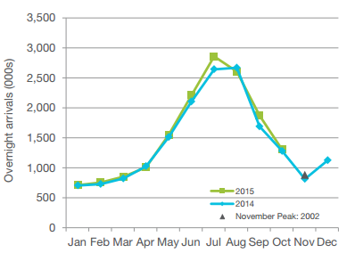
We issues a Hold Recommendation on Whistler Blackcomb (WB) with a target price of $26 using a Discounted Cash Flow Analysis and Relative Multiples valuation. Our valuation is also supported by substantial qualitative factors.

Canadian Currency Advantages
Company executives are enthusiastic about the low Canadian dollar and the tailwinds this will create for international visitor revenue growth moving forward. The sustained lull in oil prices should keep the Canadian dollar lower for longer and induce international travelers to take advantage of this as they realize the price savings they will realize by taking at trip to Canada.
Overall, WB has a strong customer draw and the company is able to effectively implement a significant price premium in its business model. We like the companies focus on profitability through high effective ticket prices, their ability to stay EBITDA cash positive in the summer, their established ties with governments, the emphasis on environmental sustainability and the recent additions to infrastructure. We believe the company will continue to be able to pay a healthy dividend in the future while continuing to see moderate growth. The low Canadian dollar should provide a tailwind to the stock price in the medium term, especially for the 2016-2017 ski season.
Available Capacity and Infrastructure
Expanded infrastructure, especially including the Sea to Sky highway expansion and facilities built due to the Olympics, helps increase traffic flow to the resort and provides substantial capacity for peak operating times. The recently built Peak 2 Peak gondola is also a favorable new addition to the mountain that will continue to help the marketability and experience of the WB summer operations.

Strong Reputation
Much of the positive outlook on WB comes from the high quality reputation that the ski community has given to the Whistler-Blackcomb ski experience. Worldwide, it is a popular destination for a premium winter vacation and it has again been rated as the Best Ski Resort in the world by Ski Magazine for 2016.
A large part of this strong reputation comes from the ability for WB to withstand harsh seasonal conditions and produce quality snow and run conditions despite suboptimal weather. WB suffers much less than its competitors in less than ideal conditions and this actually induces skiers to choose Whistler instead of various other resorts during slower growth periods. This has helped create strong floor in the business operations and brought Whistler a sustainable competitive advantage. It is very encouraging that Whistler has turned their summer operations into a positive cash EBITDA position. This means that the company is able to cover itself over the slower summer season and avoid cash flow issues as they progress through the natural seasonality of the ski resort business. We like the fact that the domestic/regional customer base is very active in the summer and can be counted on to create strong year-round activity in Whistler.
Well-established Government Regulations
Barriers to new entrants are extremely high due to the natural limitation to the supply of quality mountains and various regulatory requirements. We believe that the company is in a strong regulatory position moving forward. Company executives have close ties to the BC provincial government and Whistler is a prominent resort that has covered its basis in terms of environmental responsibility and safety. Executives are committed to working with new climate regulations as they are announced. We especially like WB’s partnership with renewable hydroelectricity under the Peak 2 Peak gondola (32Gwh annually, enough to power ~3,500 homes for a year) which further indicates the intertwined vertical value chain and long term sustainability of the business model. WB is energy neutral and actually returns power to the grid, which is a strong positive in today’s increasingly stringent environmentally conscious world.

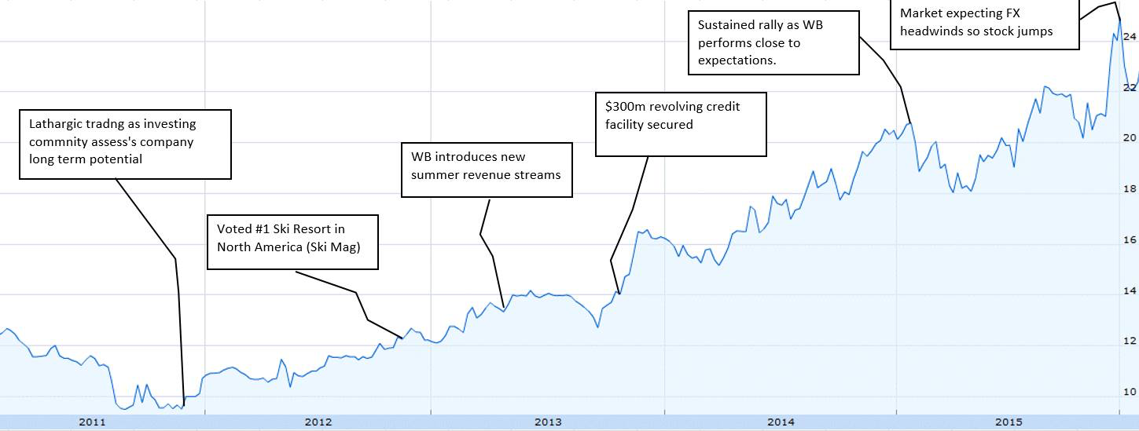
Figure 1: Share Price & News flows

Financial Analysis

Ratios | 2012 | 2013 | 2014 | 2015 | 2016E | 2017E | 2018E | 2019E | 2020E
Profitability
EBITDA Margin | 36.0% | 35.9% | 36.4% | 35.4% | 36.0% | 36.0% | 36.0% | 36.0% | 36.0%
Operating Profit Margin | 19.6% | 19.2% | 20.2% | 19.4% | 24.1% | 24.7% | 25.2% | 25.7% | 26.1%
Net Income Margin | 9.1% | 8.5% | 9.3% | 11.2% | 17.2% | 18.0% | 18.6% | 19.1% | 19.5%
Return on Assets | 1.8% | 1.7% | 2.2% | 2.6% | 3.6% | 3.9% | 4.2% | 4.4% | 4.6%
Return on Equity | 3.3% | 3.2% | 4.2% | 5.1% | 7.3% | 8.0% | 8.6% | 9.1% | 9.5%
Liquidity
Current Ratio | 134.9% | 122.8% | 61.6% | 62.7% | 68.5% | 75.2% | 83.4% | 92.9% | 103.6%
Quick Ratio | 98.5% | 86.3% | 22.3% | 16.2% | 22.0% | 28.6% | 36.8% | 46.3% | 57.0%
Cash Ratio | 91.2% | 79.9% | 14.5% | 9.7% | 15.5% | 22.2% | 30.3% | 39.8% | 50.5%
Activity
Total Inventory Turnover | 17.1 | 15.2 | 13.7 | 11.6 | 11.6 | 11.6 | 11.6 | 11.6 | 11.6
Total Asset Turnover | 0.3 | 0.3 | 0.3 | 0.3 | 0.4 | 0.4 | 0.4 | 0.4 | 0.4
Financial Leverage
Long-term Debt to Assets | 29.7% | 30.5% | 28.6% | 29.3% | 29.4% | 29.5% | 29.6% | 29.7% | 29.7%
Long-term Debt to Equity | 54.4% | 58.2% | 54.6% | 58.0% | 59.3% | 60.2% | 60.9% | 61.3% | 61.4%
Earnings per Share | $ 0.41 | $ 0.37 | $ 0.47 | $ 0.54 | $ 0.75 | $ 0.81 | $ 0.86 | $ 0.91 | $ 0.95
Dividend Payout Ratio | 237.8% | 263.2% | 207.5% | 180.6% | 129.5% | 119.8% | 112.9% | 107.3% | 102.8%
Interest Coverage Ratio | 2.66 | 2.76 | 2.77 | 4.25 | 7.42 | 7.89 | 8.27 | 8.61 | 8.92
Financial Leverage Degree | 1.60 | 1.57 | 1.57 | 1.31 | 1.16 | 1.15 | 1.14 | 1.13 | 1.13

Increasing Margins Supported by Existing Infrastructures

Whistler Blackcomb has experienced a period of immense infrastructure constructions, which led to its high depreciation expenses. Currently Both the Whistler and Blackcomb Mountain have a combined lift capacity of 65,507 Skiers/Hour, which far exceeds its current visit numbers. With CAPEX staying low to only meet maintenance requirements, and depreciation being stable, WB will be able to maximize net-income, cash flow, and utilize its existing infrastructures to meet future demands.

Consistent Dividend Level Shows Management Confidence

Whistler Blackcomb has paid $0.97/Share in dividends consistently over the past four years, dividend numbers far exceed WB’s EPS. This is seen as signs of high confidence level of the management team in WB’s future. The dividend payout ratio of dividends relative to earnings was 180.6% in 2015, decreasing from 263.2% in 2013; we project the payout ratio will progressively decrease to below 100% over the next five years as earnings increase in step with increasing operating profits margin. In the meantime, the firm has adequate cash flow to maintain the current dividend because reported earnings are depressed by the large depreciation expense related to past capital investment. However, it is important to note that in the next few years, if WB is faced with stagnant revenue growth, the company may be required to issue new loans to sustain the high dividend level of past years.

High Debt Poses Threat to Company’s Cash flows

Whistler Blackcomb’s current available cash is relatively low compared to past years. With long-term debt amount of $232.4 Million Dollar, WB’s current cash of 5.68 Million may not be sufficient to maintain the high level of dividend or begin paying back its debt.

Financial Leverage

Degree of financial leverage has decreased steadily, showing both WB’s decrease in dependency on debt and also its ability to pay back its debt. As part of our assumptions, we project debt levels to remain stable as WB will not have large CAPEX plans, and we believe WB will not have much excess cash flow to cut down on existing debt. However, given the amount of financing options WB has, we strongly believe in WB’s ability to fulfill its debt obligations as its revenue will see significant increases in the next few years.

ROE Composition

ROE is expected to increase from 5.1% to 9.5% in the next 5-year period. The main drivers of this are Net Income Margin increases as result of low CAPEX and depreciation as well as the decrease in financial leverage overtime.

Stability in Debt Levels Due to Slowdown in Expansion and Increase in Net Income

Debt level will likely stabilize as a result of cut in CAPEX, retained earnings is expected to increase as EPS exceeds the dividend level of $0.98/Share. Therefore degree of financial leverage will likely decrease, as well as an increase in the level of interest coverage ratio.

Valuation

For the valuation of Whistler Blackcomb, we utilized two valuation methodologies, 5-year Discounted Cash Flow Analysis and Comparable Multiples Valuation. We used 50% weighting for both of these valuation methodologies to arrive at an intrinsic share value of $22.16.

DCF Model
A 2-Stage Discounted Cash Flow Model was used to estimate the intrinsic value of WB’s share price due to the predictability of cash flows in relation to growth and profitability. The model is forecasted 5-years. The first growth phase of the forecast represented our opinions of strong revenue growth as result of the depreciating Canadian Dollar, changing visitor mix, as well as the effects of weather conditions. The result of the DCF Model produced an intrinsic value per share of $21.57.

This model is driven by Free Cash Flow to Firm, which represents Operating Income after tax plus D&A plus Capex plus Net Working Capital. The DCF was expanded into a 10-year time frame to confirm with the consistency of the 5-year model, which produced supportive results.

Inputs for this model were formulated using guidance from historical performance, industry outlook, assessments of WB’s competitive positioning, as well as guidance from management. The DCF is most sensitive to the following factors, the derivations of which are explained below:

Revenue
Two important metrics were used to forecast revenue, total visits and RPV (Revenue per Visit). For total visits in the year 2016, we believe the number will increase by 1.24% as a result of increase in destination visits and stable local visits. We believe that the low Canadian Dollar and weather condition will attract more international visitors, while local visitor numbers are believe to be stable as a result of the turmoil in the Canadian economy and job market.

Operating Costs
WB’s operating costs plus SG&A costs have been relatively stable in the past 5 years, fluctuating around 64% with 1% deviation, and we don’t expect a significant increase or decrease in these major costs in the near future.

Capital Expenditure
Capital Expenditure are estimated based on WB’s depreciation costs. WB has gone through heavy capital investment in past years, and their capacity has not been closely met. Therefore we believe CAPEX remain low at the maintenance level, which tracks WB’s depreciation of its existing PPE.

Weighted Average Cost of Capital
The after tax cost of debt was calculated using its most recent cost of debt of 3.98% for its current long-term loans taken from WB’s 2015 Management Discussion, and it’s tax rate of 27% is calculated using data from WB’s most recent financial report. The target capital structure is calculated using its most recent long-term debt amount divided by the most recent market value of its equities.

The cost of equity was calculated using the Capital Asset Pricing Model (CAPM). The current 10-year Canadian Bond Yield is 1.32%, however we believe this historical low number is not an accurate reflection of the forward risk-free rate in Canada, therefore we have taken the risk-free rate of 3% to reflect likely future rate hikes.

Assumptions
Risk Free Rate | 3.00%
Risk Premium | 6.50%
Expected Market Return | 9.50%
Beta | 0.8
Cost of Equity | 8.20%
Cost of Debt | 3.98%
Tax Rate | 27.20%
After-Tax Cost of Debt | 2.90%
Market Cap | 878.30
Debt to Equity Ratio | 0.26
WACC | 7.09%
Perpetual Growth Rate | 2.00%
Through a regression test of WB historical returns against the S&P TSX Composite Index returns, a beta of 0.6 was derived. However according to management guidance, Whistler Blackcomb’s WACC is of 8%, which brings the beta up close to 1.0 with other inputs fixed. According to New York University’s Sector Beta Database, the average beta for the hotel/gaming sector is 0.97, and the beta for entertainment is 1.21, therefore the beta of 0.6 appears quite low for a company like Whistler Blackcomb. The factor which may have contributed to the relatively low beta is WB’s high institutional holding of more than 75%. With the stock rather closely held, there would be limited shares float, which may bias historical beta to be on the low side. Therefore it is logical to use an average forward looking beta of 0.8 as the expected beta of Whistler Blackcomb.

Terminal Growth
As The Snow Sport Resort Sector continues to reach the point of saturation, the revenue growth of WB will also slowdown to the point of the average inflation of 2%, which is accounted for in the 5th year terminal growth rate.

Comparable Multiples Valuation

While the DCF model was the main valuation approach, we also analyzed valuations of Comparable Firms. With the EV/EBITDA multiple, and our forecasted EBIDTA of Whistler Blackcomb, we calculated an relative value of $22.74 per share in one-years’ time.
Name | Ticker | Mkt Cap (USD) Millions | Price (I) | Net Debt | EV / EBITDA | Dividend Yield (%)
Whistler Blackcomb Holdings | WB CN | 643.00 | 16.92 | 169.24 | 12.37 | 4.2%
Extended Stay America Inc. | STAY US | 2659.72 | 13.00 | 2709.92 | 9.84 | 3.9%
Marriott Vacations World | VAC US | 1516.60 | 48.82 | 486.96 | 8.86 | 1.5%
Hyatt Hotels Corp | H US | 5619.68 | 40.48 | 743.00 | 9.09 | 0.0%
Starwood Hotels & Resorts | HOT US | 10482.73 | 62.03 | 1295.00 | 9.78 | 3.4%
Hilton Worldwide Holdings | HLT US | 17863.00 | 18.09 | 10188.00 | 10.38 | 0.8%
Vail Resorts Inc. | MTN US | 4343.38 | 119.85 | 790.77 | 14.01 | 1.9%
Royal Caribbean Cruises LTD | RCL US | 16187.26 | 73.58 | 8545.49 | 11.73 | 1.8%
Carnival Corp | CCL US | 35754.18 | 45.51 | 7392.00 | 10.23 | 2.4%
Average |  | 10563.28 | 48.70 | 3591.15 | 10.70 | 2.2%

Companies selected as appropriate comparables for the relative valuation are companies in the Entertainment Resort and Hospitality Sector. With Vail Resorts Inc. being the closest comparable as both firms operate in the Winter Sport Resort business. However MTN operates worldwide and its revenue streams come from its resorts, lodging and real estate business. MTN’s EV/EBIDTA multiple is also the highest among its peers, which reflects the stronger confidence in the future growth of MTN when compared to WB. However it is important to note that the Dividend Yield of MTN is lower than WB, and its dividends have been quite inconsistent in the past 5 years, while WB has had a consistent dividend number for the last four years.

The rest of the comparable firms selected are leading players in the hospitality sector, note that the generally low EV/EBITDA multiples reflect the limited growth potential of these firms and its mature business stage.
19.58%

Investment Risks

Climate/Climate Risk
The main investment risk being the impact of climate and weather patterns as global warming has seen a minimal change in temperature on the mountain compared to over a one degree change at the village base. It is an El Niño year so this has the potential to hinder the expected snowfall that WB will receive. Whistler’s capability to expand is also a potential limitation as it is difficult to increase the number of runs they currently have with the given terrain. They also have a limited ability to be innovative as their growth of offerings is fairly stagnant.

Public Relation Risk
Risk | Mitigation
Climate | Reliable snowmaking Infrastructure
Currency | Economies of Scale
Public Relation | Quality Mountain Safe Team
Interest Rate | Use of interest rate swaps
Seasonality | Increasing Summer Revenue Stream
Workforce | Increase Hiring Frequency
Regulation | Detailed Agreement, High Standard
Whistler faces numerous risks when it comes to company image. If they fail to maintain the quality and safety of their runs in regards to signage, the risk of visitors getting lost, in an accident or in an avalanche will be severely impacted. When media catches wind of such detrimental events, stories will air quickly and Whistlers image shall be tarnished for the time being as visitors may get turned off as the perception of their safety may be in jeopardy.

Currency Risk / Consumer Demand
Consumer demand risk has a moderate impact as a significant market downturn abroad will cause declining annual skier visits causing a greater reliance on regional demand due to a decrease in international buying power. There is quite a big risk of volatile fluctuations in currency as the low Canadian dollar encourages more international visitors as Whistler becomes a much more inexpensive option. They are also susceptible to being affected by variations in airline ticket price
abroad which can potentially decline WB’s international visitation potential. The ability to continue paying dividends is also a risk that investors are surely going to take into account.

Credit Facility and Interest Rate risk
This restricts ability of entities forming part of WB’s group to incur or guarantee additional indebtedness, pay dividends, make other distributions, restricted payments and make loans. Recently on Sept. 30th 2015, the underlying floating interest rate on approximately. 53% of the company’s debt outstanding was effectively fixed for the term of their $125 million interest rate swap with a Canadian Bank.

Seasonality of Operations Risk
It plays a large factor as 85% of their core revenue source comes during the winter months, primarily attributable to sales of lift tickets and passes, purchased by skiers and boarders. The risk of operational inefficiencies occurring during peak revenue times would prove to be detrimental for the overall net income as well as reputation. If a poor year of snowfall occurs, Whistler’s dynamic of international to regional visitors would be impacted and they would have to heavily rely on their summer operations to make up for lost revenues causing a constraint on the utility of resources and inefficiency of summer operations.
Seasonal Workforce Risk
They depend on a seasonal workforce and as demand fluctuates, where too many or few employees are hired during peak times in the season. As many employees are hired from abroad, it is in Whistlers best interest to maintain specific accommodation for them as to not impose on current hotels and residential areas.

Environmental Regulation Risk
This risk is a pivotal factor as it considers the stringent restrictions on water consumption which can be excessive due to snowmaking which Whistler would need to monitor. Keeping track of waste is also important for Whistler’s image as they seek to minimize their carbon footprint which can be costly. Failure to do so may tarnish their perception in global markets. In terms of expansion of the mountain and village facilities, agreements of approval need to be made with the first nations before any project is taken on.

Disclosures:
Ownership and material conflicts of interest:
The author(s), or a member of their household, of this report [holds/does not hold] a financial interest in the securities of this company.
The author(s), or a member of their household, of this report [knows/does not know] of the existence of any conflicts of interest that might bias the content or publication of this report. [The conflict of interest is…]
Receipt of compensation:
Compensation of the author(s) of this report is not based on investment banking revenue.
Position as an officer or director:
The author(s), or a member of their household, does [not] serves as an officer, director or advisory board member of the subject company.
Market making:
The author(s) does [not] act as a market maker in the subject company’s securities.
Ratings guide:
Banks rate companies as either a BUY, HOLD or SELL. A BUY rating is given when the security is expected to deliver absolute returns of 15% or greater over the next twelve month period, and recommends that investors take a position above the security’s weight in the S&P 500, or any other relevant index. A SELL rating is given when the security is expected to deliver negative returns over the next twelve months, while a HOLD rating implies flat returns over the next twelve months.
Disclaimer:
The information set forth herein has been obtained or derived from sources generally available to the public and believed by the author(s) to be reliable, but the author(s) does not make any representation or warranty, express or implied, as to its accuracy or completeness. The information is not intended to be used as the basis of any investment decisions by any person or entity. This information does not constitute investment advice, nor is it an offer or a solicitation of an offer to buy or sell any security. This report should not be considered to be a recommendation by any individual affiliated with CFA Society Okanagan, CFA Institute or the CFA Institute Research Challenge with regard to this company’s stock.

Appendix 1:

Source: Bloomberg LP

Appendix 2 (Porters 5 Forces Framework):
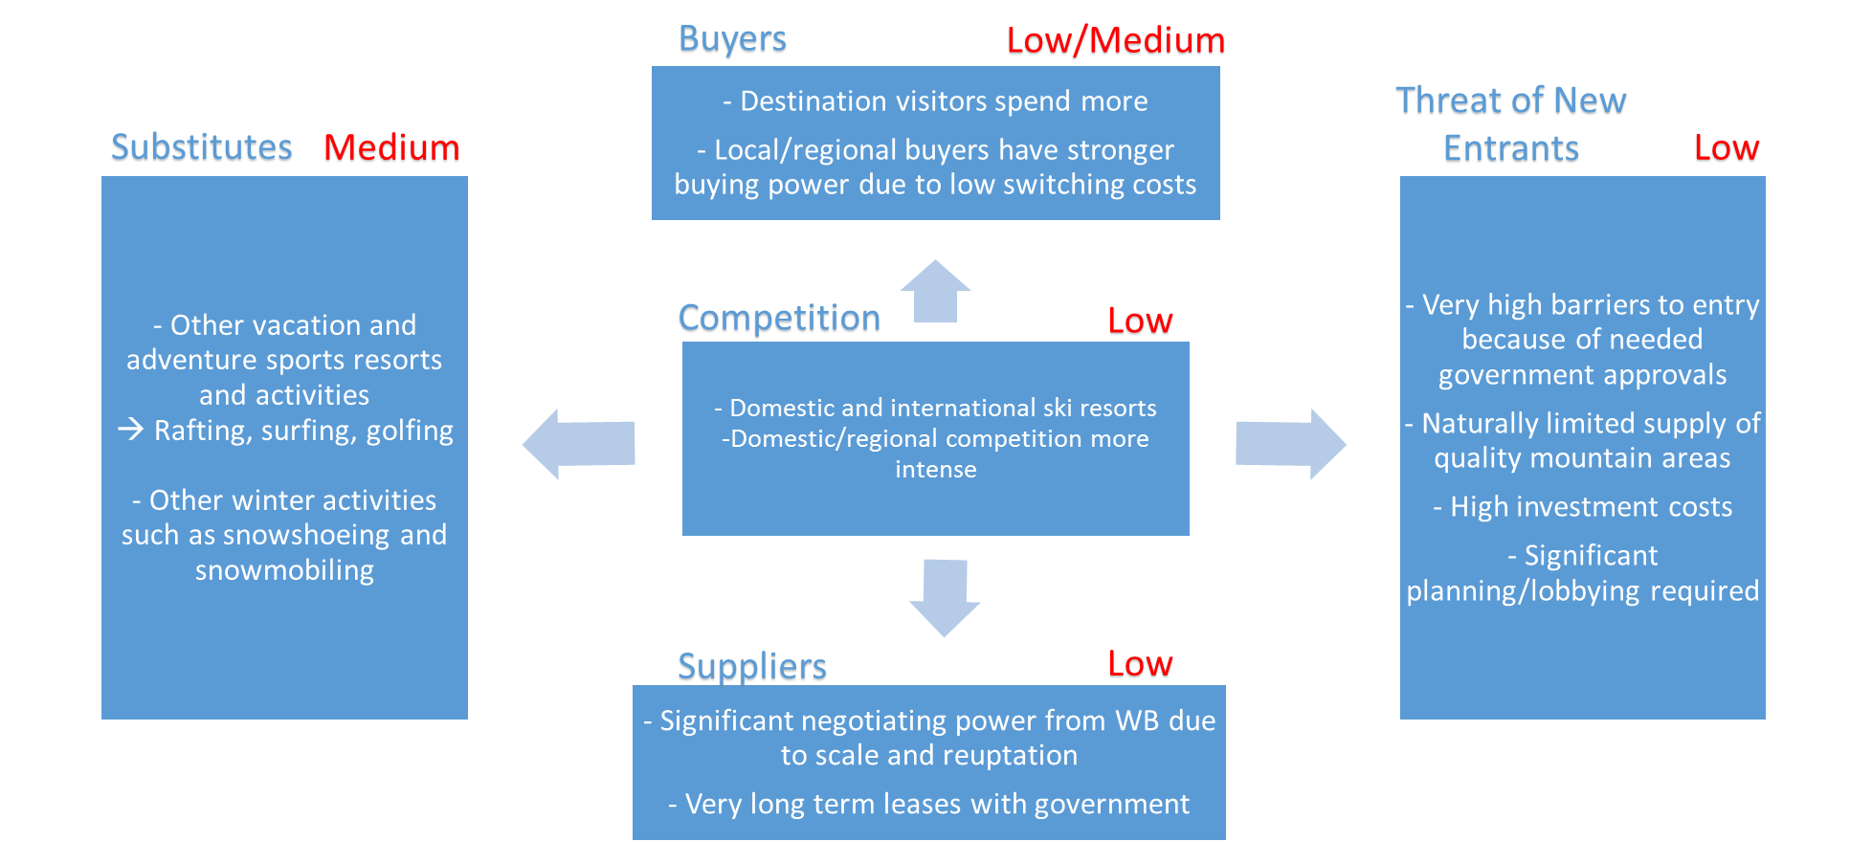
Source: Team Research

Appendix 2 (Correlation between CAD/USD and WB stock price):

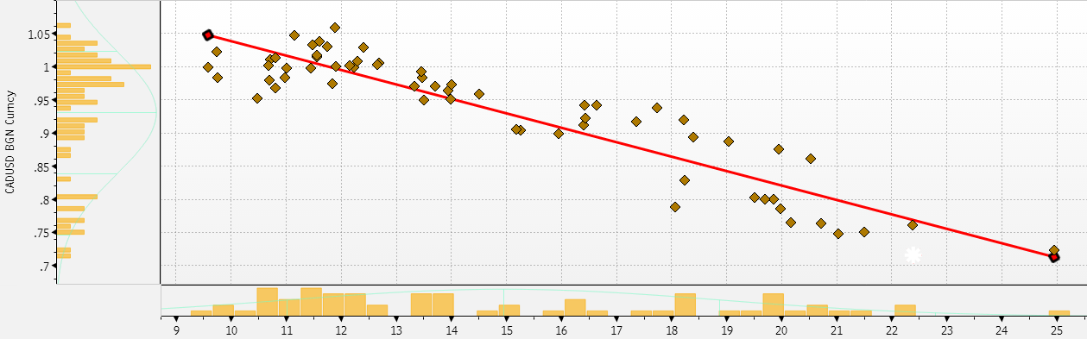

Source: Bloomberg LP

Appendix 3: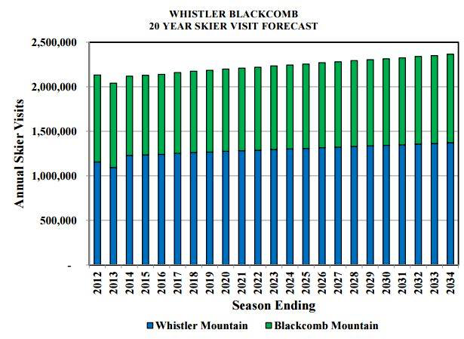

Source: Whistler Blackcomb Holdings LP
Appendix 4 (Discounted Cash Flow Valuation):

Appendix 5:

Appendix 6:

Appendix 7:

Appendix 8:
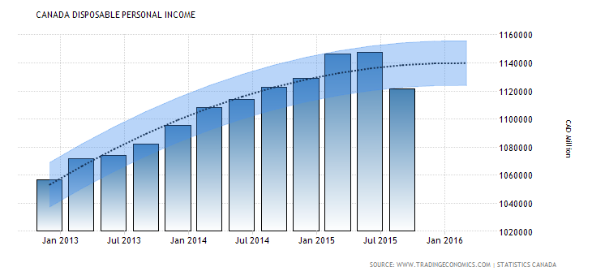
Source: Statistics Canada

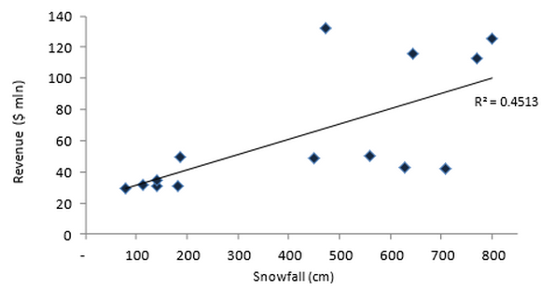
Appendix 9 (Correlation between snowfall and revenue):
Source: Raymond James

